TASK 1:
MOV AX 3d ; syntax error -> it should be mov ax, 3d
MOV 23, AX ; syntax error -> destination must be a register: mov ax,23
MOV CX, CH ; no error found
MOVE AX, 1h ; incorrect mnemonic -> right mnemonic is MOV ax, 1h
ADD 2, CX ; immediate operand not allowed in destination
ADD 3, 6 ; destination operand is invalid
INC AX, 2; invalid syntax as it adds 1 and does not take second operand
TASK 2:
;my name is Arham
.code
main PROC

mov al, 'a'
movzx eax, al
call writedec
call crlf

mov ax, 'r'
movzx eax, ax
call writedec
call crlf

mov bl, 'h'
movzx eax, bl
call writedec
call crlf
exit
OUTPUT:
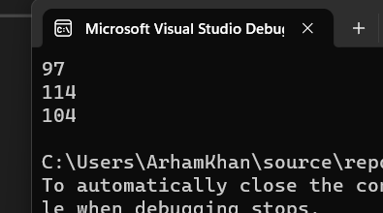

TASK 3:
.data
varB BYTE +10
varW WORD -150
varD DWORD 600

.code
main PROC
mov eax, 0
movsx ebx, varB
mov eax,ebx
call writeint
call crlf

mov eax, 0
mov bx, varW
movsx eax,bx
call writeint
call crlf

mov eax, 0
mov ebx, varD
movzx eax,bx
call writeint
call crlf

OUTPUT:
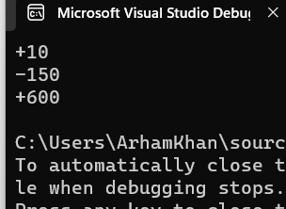
TASK 4A:
.code
main PROC

;EAX = 89 + 75Fh - 46o - 28 + 1101b

mov eax, 0
mov eax,89d
add eax,75Fh
sub eax,46o
sub eax, 28d
add eax,1101b
call writedec

OUTPUT:
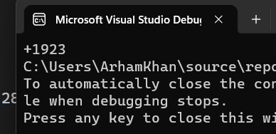
TASK 4B:
.data
;TASK 4 - B
;EAX = val1 + val2 - 654h + val3
val1 DWORD 25h
val2 BYTE 36o
val3 WORD 20d
.code
main PROC

mov eax, 0
mov eax, val1
movzx ebx, val2
add eax, ebx
movzx ebx, val3
add eax, ebx
call writeint
OUTPUT:
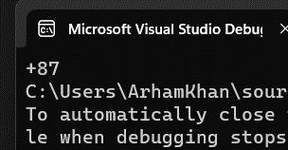
TASK 5:
.data
;lab 4 - task 5
secInDay = 24*60*60
.code
main PROC

mov eax,0
mov eax, secInDay
call writedec
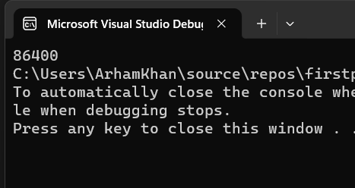
TASK 6:
.data
;lab 4 - task 6
A dword 0FF10h
B dword 0E10Bh
.code
main PROC

mov eax, A
mov ebx, B
call dumpregs
call crlf
xchg eax,ebx
call dumpregs
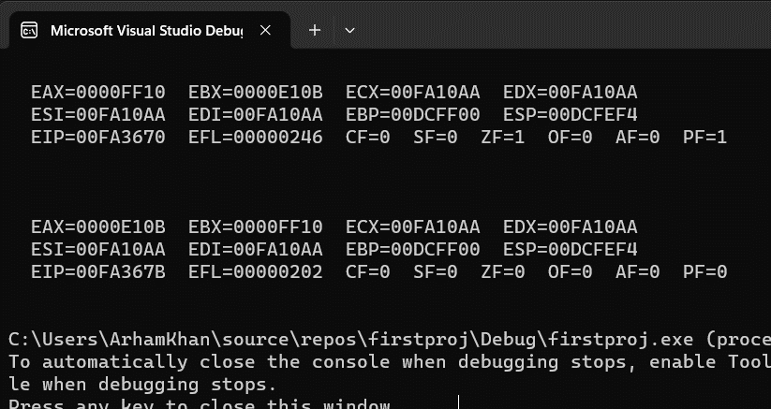
TASK 7:
.data
; lab 4 - task 7
val1 BYTE 10h
val2 WORD 8000h
val3 DWORD 0FFFFh
val4 WORD 7FFFh
.code
main PROC

movzx eax, val2
call dumpregs
call crlf
inc eax
call dumpregs

movzx eax, val1
movzx ebx, val2
sub eax,ebx
call dumpregs

movzx eax, val4
movzx ebx,val2
sub eax, ebx
call dumpregs
